Retrieving Data Using the SQL SELECT Statement
1. Determine the Structure of DEPT Table and its Contents.
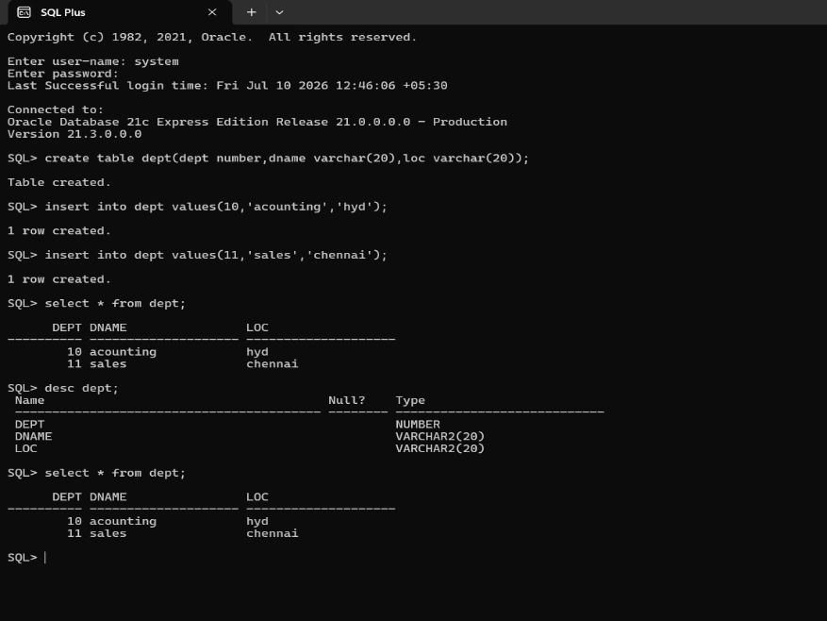
2. Determine the Structure of EMP Table and its Contents.
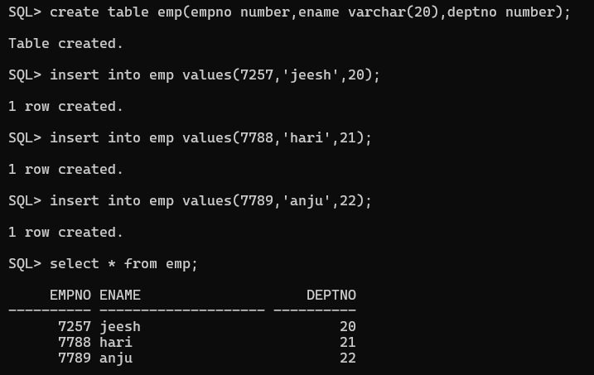
3. Display the Ename and Deptno from Emp table whose Empno is 7788.
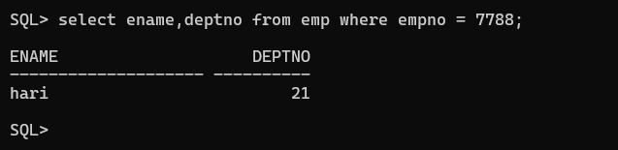

Restricting and Sorting Data
- Display the Ename,Sal,Comm from Emp table who earn commission and sort the records in descending order of Salary and Comm. Use column’s numeric position in the ORDER BY clause
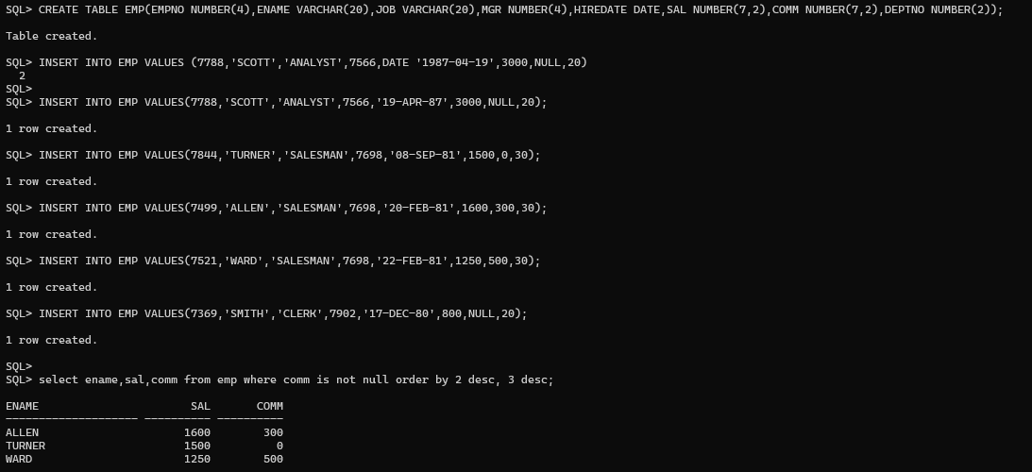
- The HR department needs a query to display all unique job codes from the EMP table.

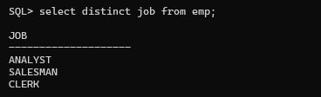

- The HR department wants more descriptive column headings for its report on employees. Name the column headings Emp #, Employee, Job, and Hire Date, respectively by giving Column Alias

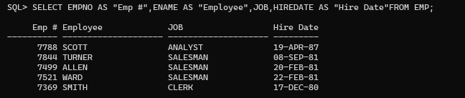

- The HR department has requested a report of all employees and their job IDs. Display the last name concatenated with the job ID (separated by a comma and space) and name the column Employee and Title by giving Column Alias.

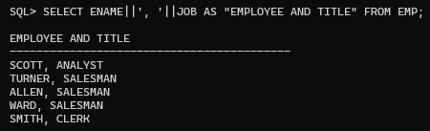
5. To familiarize yourself with the data in the EMP table, create a query to display all the data from that table. Separate each column output by a comma. ENAME,JOB,HIREDATE,MGR.Name the column title THE_OUTPUT.
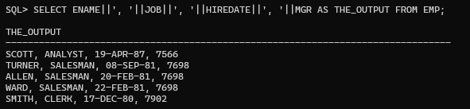
6. Create a report to display the ename, job , and Hiredate for the employees name is SCOTT or TURNER. Order the query in ascending order by hiredate.
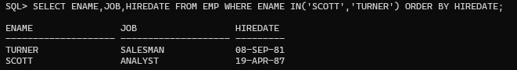
7. Display the ename and department number of all employees in departments 20 or 30 in ascending alphabetical order by ename.
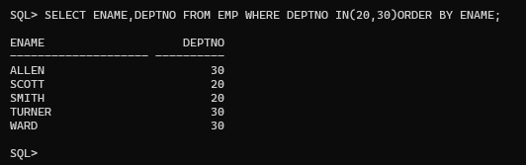
8. Modify the previous query to display the last name and salary of employees who earn between 2000 and 3000 and are in department 20 or 30. Label the columns Employee and Monthly Salary, respectively giving Column Alias
9. The HR department needs a report that displays the last name and hire date for all employees who were hired in 1981
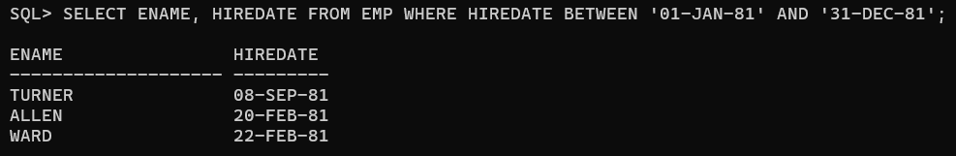
10. Display the Ename, Sal of employees who earn more than an amount the user specifies after a Prompt.
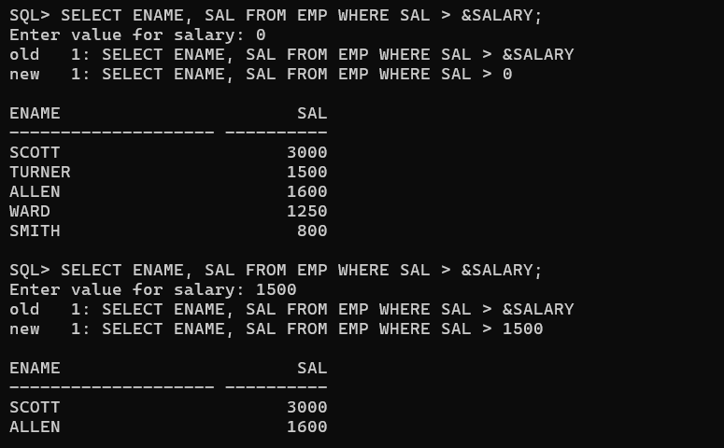
11. Create a report to display the last name and job title of all employees who do not have a manager.
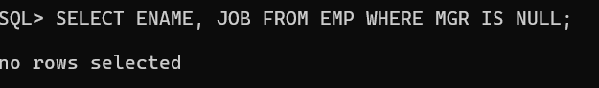
12 Create a query that prompts the user for Manager ID and generate EMPNO,ENAME, SAL,DEPTNO. The user should have the ability to sort the records on a selected Column.
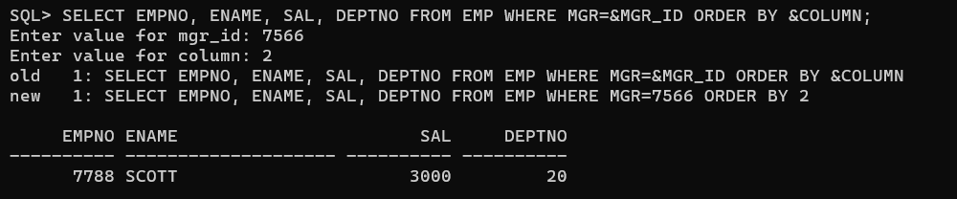
13. The HR department wants to run reports based on a manager. Create a query that prompts the user for a MGR and generates the empno, ename, salary, and department for that manager’s employees. The HR department wants the ability to sort the report on a selected column
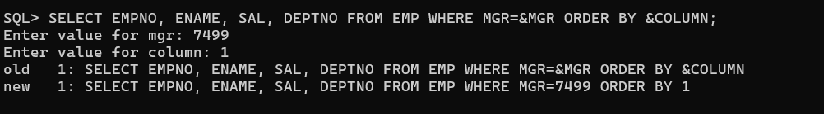
14. Display all employee last names in which the third letter of the name is A


15. Display the last name of all employees who have both an A and an S in their ename
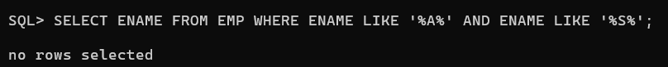
16. Display the Ename, Job, Sal for all employees whose jobs are CLERK and whose salary is in 800 or 950 or 1300.
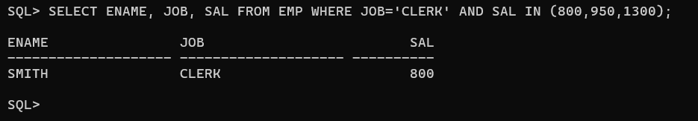

Using single row functions to Customize The Output
- Write a query to display the current date. Label the column Date.
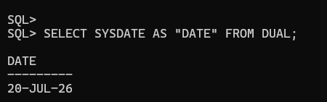

- The HR department needs a report to display the employee number, last name, salary, and salary increased by 15.5% (expressed as a whole number) for each employee. Label the column New Salary.
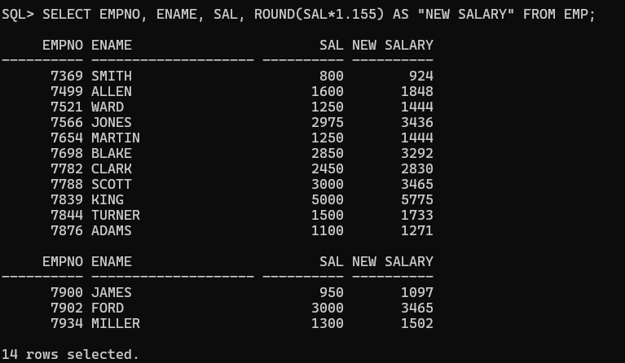
- Modify the previous query to add a column that subtracts the old salary from the new salary. Label the column Increase.
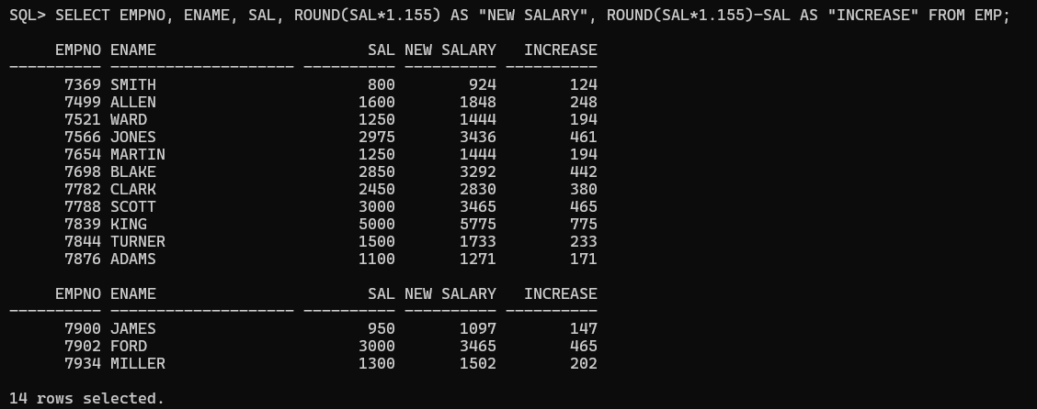
- Write a query that displays the employee name (with the first letter uppercase and all other letters lowercase) and the length of the employee name for all employees whose names start with J, A, or M. Give each column an appropriate label. Sort the results by employee names.
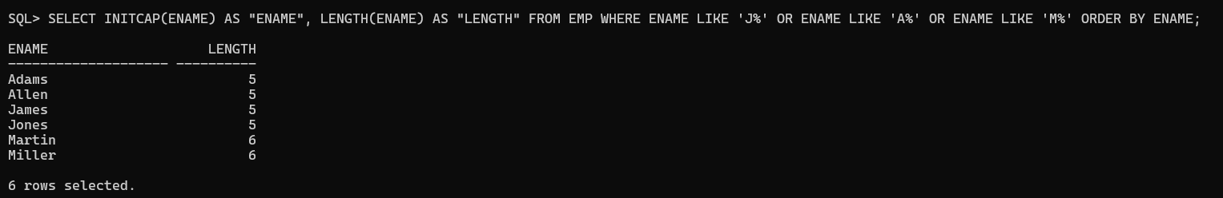

- Rewrite the query so that the user is prompted to enter a letter that starts the employee name. For example, if the user enters H, display all employees whose names start with H.
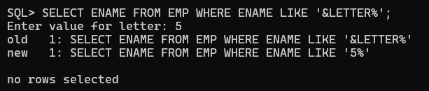

- The HR department wants to find the length of employment for each employee. Display the employee name and calculate the number of months between today and the hire date. Label the column MONTHS_WORKED. Round the months to the nearest whole number and order the results by months worked.
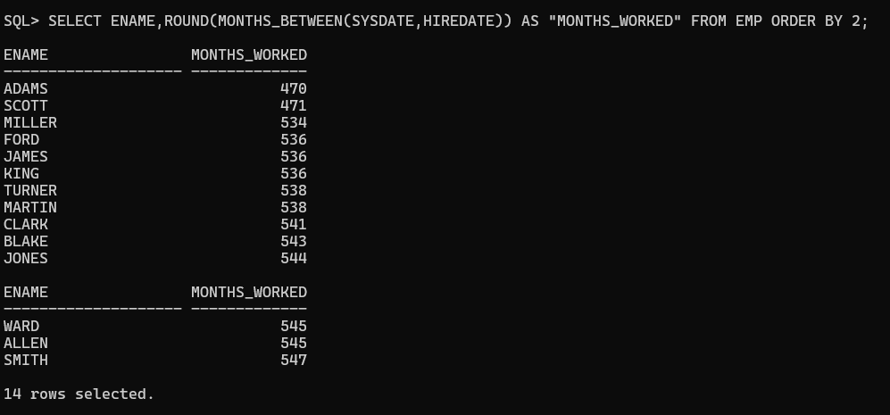
- Create a report that produces the following for each employee: "<employee name> earns <salary> monthly but wants <3 × salary>". Label the column Dream Salaries.
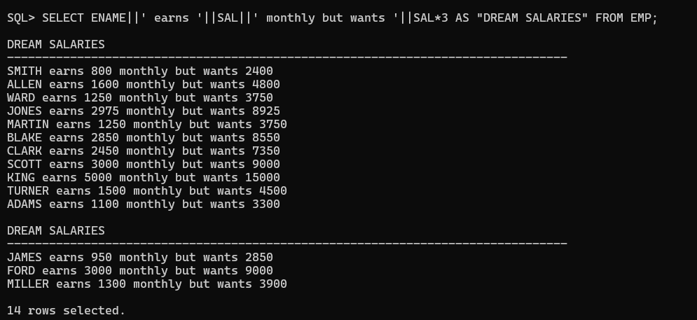

- Create a query to display the employee name and salary for all employees. Format the salary to be 15 characters long, left-padded with the $ symbol. Label the column SALARY.

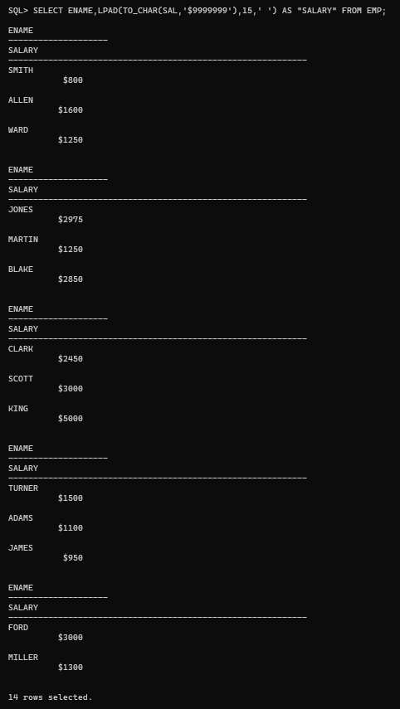

- Display each employee's name, hire date, and salary review date, which is the first Monday after six months of service. Label the column REVIEW. Format the date like "Monday, the Thirty-First of July, 2000."

- Display the employee name, hire date, and the day of the week on which the employee started. Label the column DAY. Order the results by the day of the week, starting with Monday.
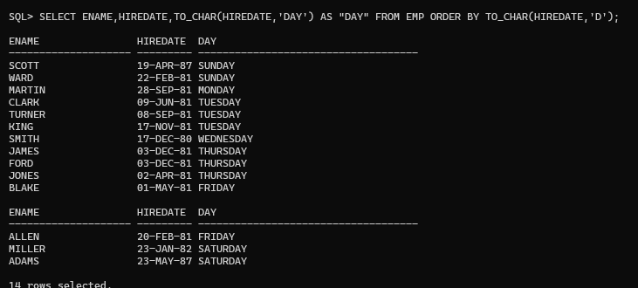
- Create a query that displays the employee names and commission amounts. If an employee does not earn commission, show "No Commission." Label the column COMM.
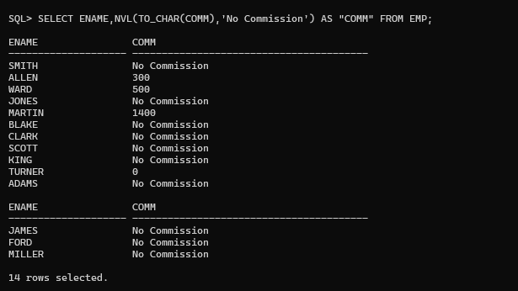
- Create a query that displays the first eight characters of the employee names and indicates the amount of their salaries with asterisks. Each asterisk signifies $1000. Sort the data in descending order of salary. Label the column EMPLOYEES_AND_THEIR_SALARIES.
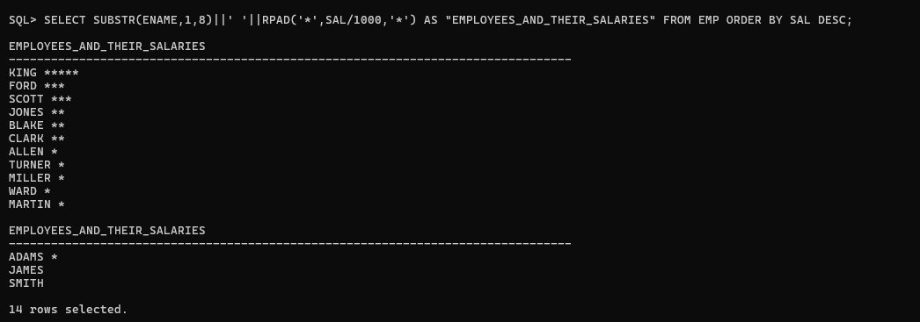
- Using the DECODE function, write a query that displays the grade of all employees based on the value of the JOB column using the following mapping: PRESIDENT → A MANAGER → B SALESMAN → C CLERK → D
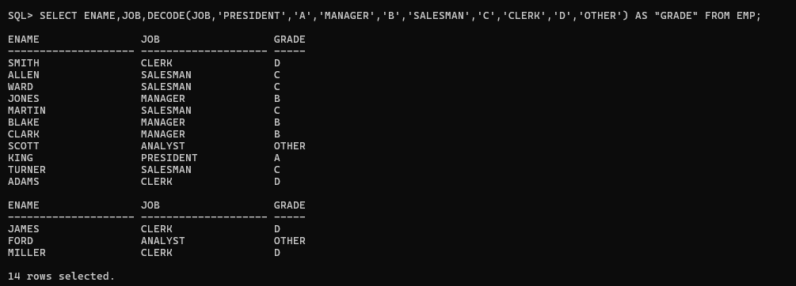
- Rewrite the statement in the previous exercise using the CASE syntax.
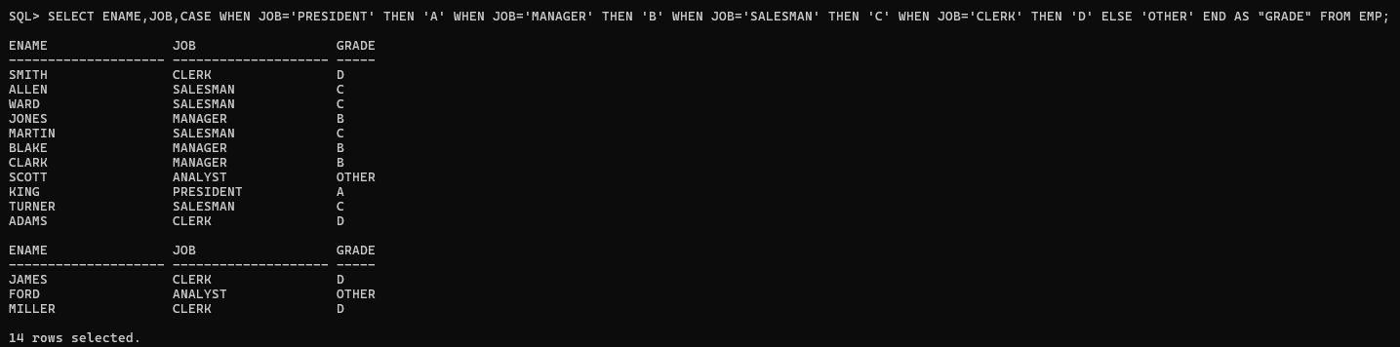

Reported Aggregated Data Using The Group Functions

1.Find the highest, lowest, sum, and average salary of all employees. Label the columns Maximum, Minimum, Sum, and Average, respectively.
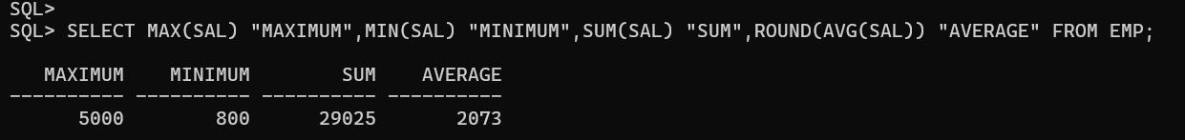

2.Round your results to the nearest whole number.

3.Modify the above query to display the minimum, maximum, sum, and average salary for each job type.
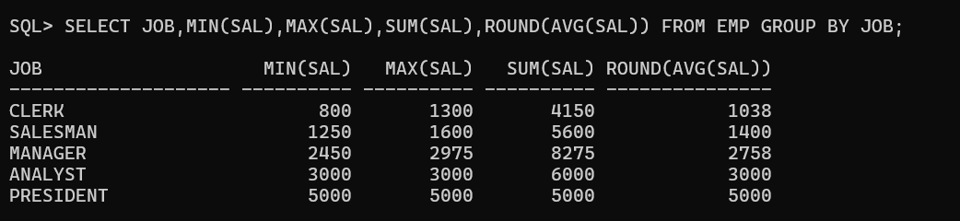
4.Write a query to display the number of people with the same job.
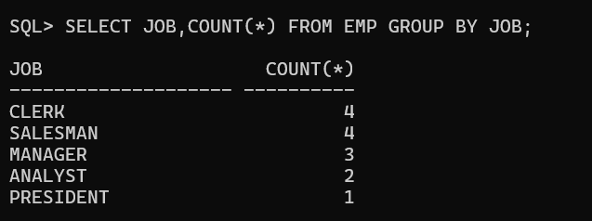

5.Determine the number of managers without listing them. Label the column Number of Managers.

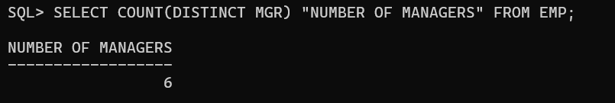

6.Find the difference between the highest and lowest salaries. Label the column DIFFERENCE.

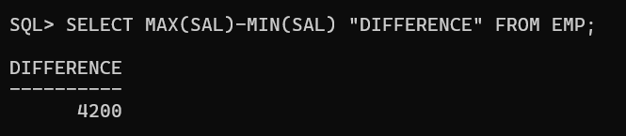

7.Create a report to display the manager number and the salary of the lowest-paid employee for that manager. Exclude anyone whose manager is not known. Exclude any groups where the minimum salary is $2000 or less. Sort the output in descending order of salary.

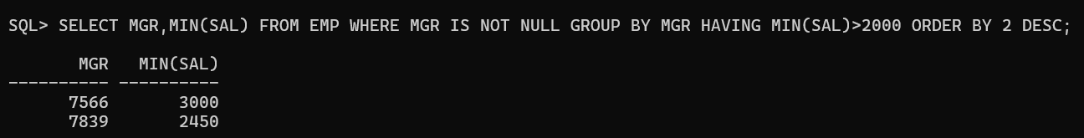

8.Create a query to display the total number of employees and, of that total, the number of employees hired in 1980, 1981, and 1982. Create appropriate column headings.

Using The Set Operators

1.Create a matrix query to display the job, the salary for that job based on department number, and the total salary for that job, for departments 10, 20, and 30. Give each column an appropriate heading.

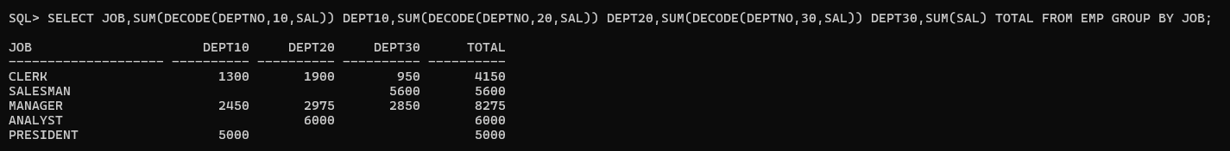

2.Using SET OPERATOR, display the DEPTNO and SUM(SAL) for each department, JOB and SUM(SAL) for each job, and the Total Salary.

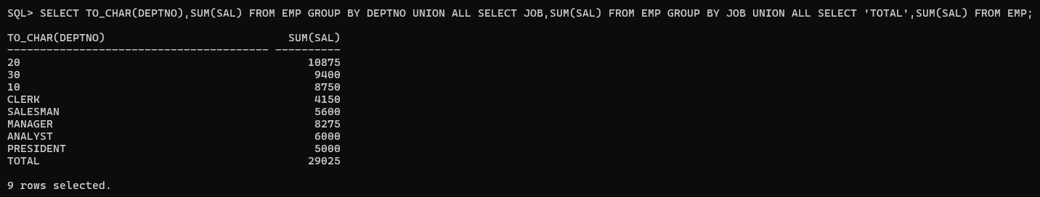

3.Using SET OPERATOR, display the JOB and DEPTNO of employees working in departments 20, 10, and 30, in that order

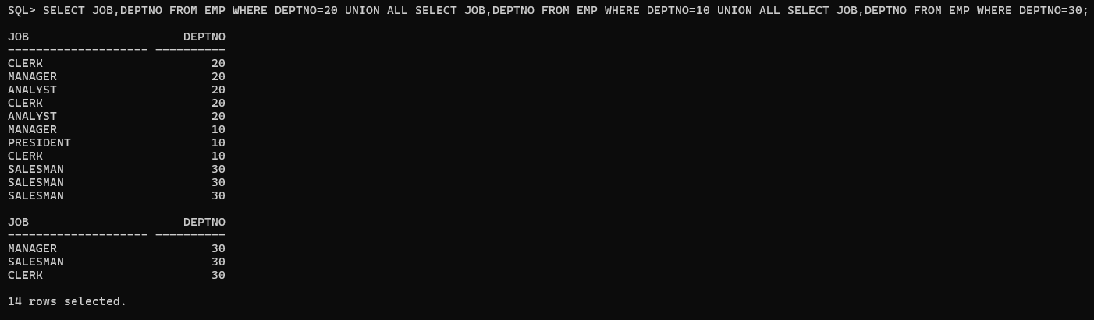

Displaying Data from Multiple Tables Using Joins

1.Write a query for the HR department to produce the addresses of all the departments. Use the EMP and DEPT tables. Show the EMPNO, ENAME, SAL, DNAME, and LOC in the output. Use a NATURAL JOIN to produce the results.

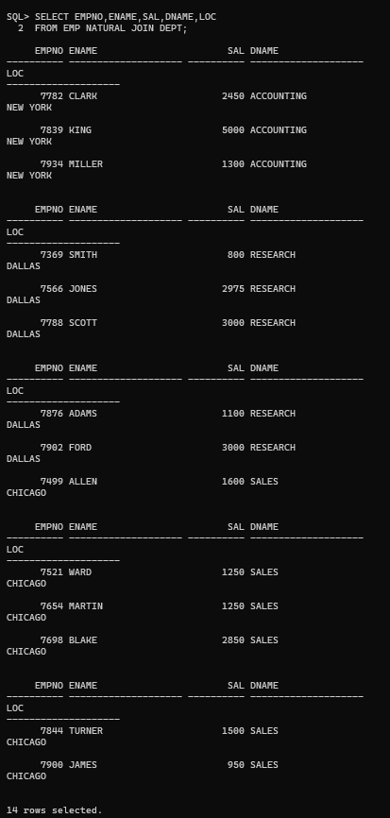

2.The HR department needs a report of all employees. Write a query to display the JOB, MGR, SAL, COMM, and DNAME of employees whose JOB is SALESMAN.
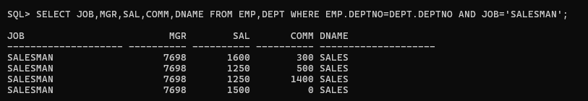

3.The HR department needs a report of employees in DALLAS. Display the ENAME, JOB, DEPTNO, and DNAME for all employees who work in DALLAS.
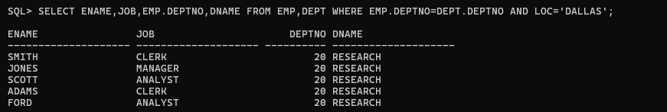

4.Create a report to display the employees' ENAME and EMPNO along with their manager's ENAME and EMPNO. Label the columns Employee, Emp#, Manager, and Mgr#, respectively.
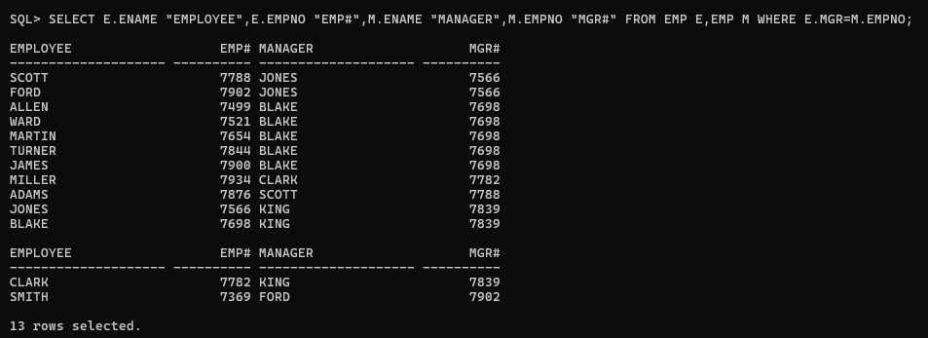

5.Modify the previous query to display all employees including KING, who has no manager. Order the results by the employee number.
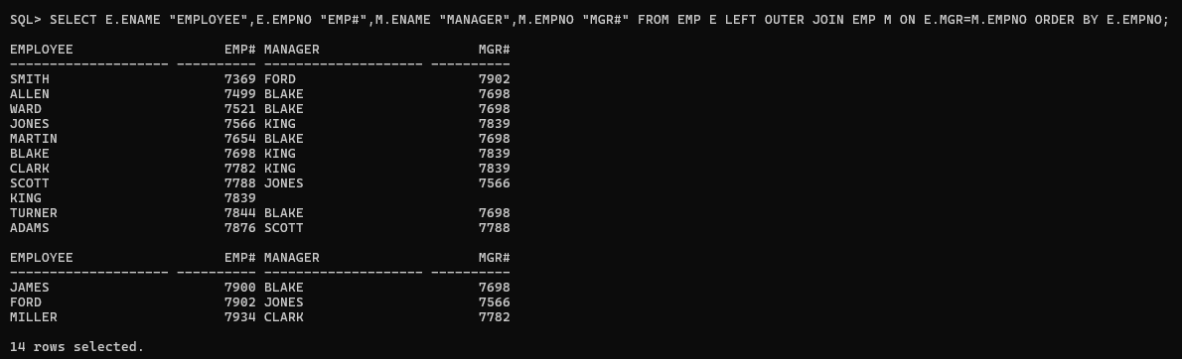

6.The HR department needs a report on job grades and salaries. To familiarize yourself with the SALGRADE table, first show the structure of the SALGRADE table. Then create a query that displays the employee name, job, department name, salary, and grade for all employees.
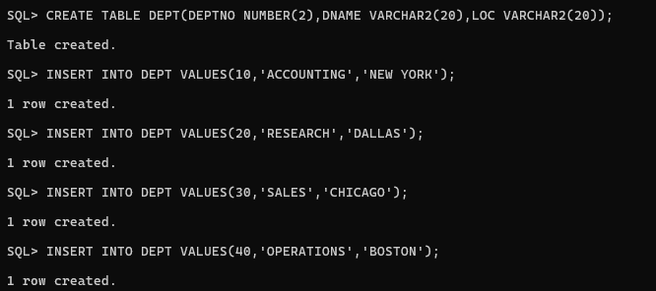
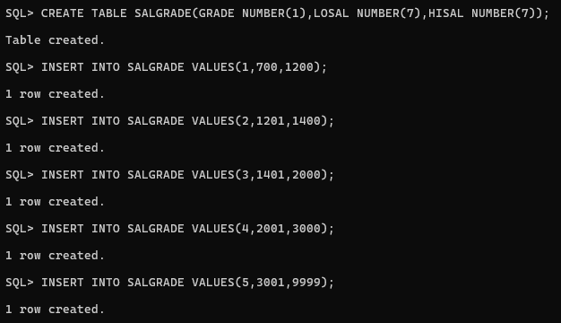

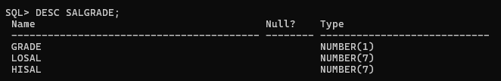

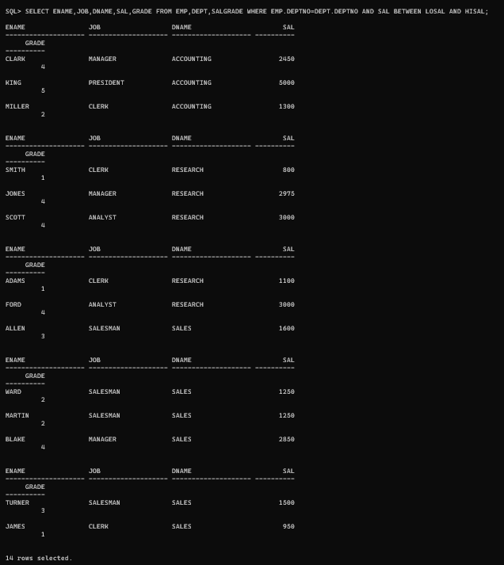

7. Display the ENAME and DNAME of all employees. Also display those department names that do not have any employees working.

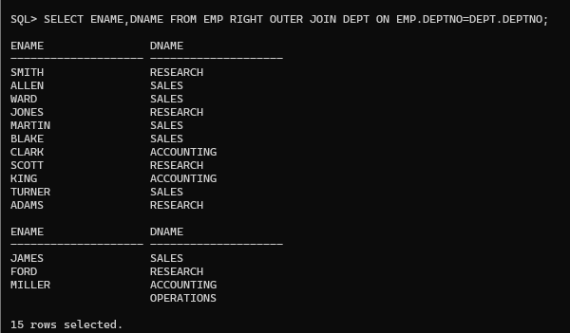

8. The HR department needs to find the names and hire dates for all employees who were hired before their managers, along with their managers' names and hire dates.

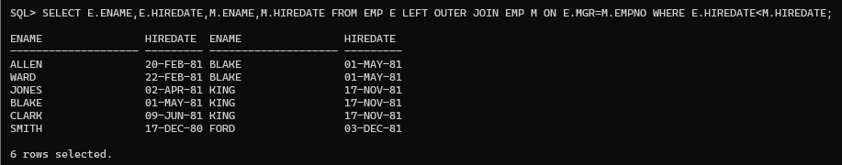

9. Display the EMPNO, ENAME, DNAME, and LOC of those employees who are working as CLERK. Use the USING clause.

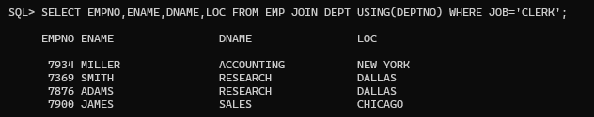

10. Display the ENAME, SAL, MGR, and DNAME of employees whose salary is more than 2000. Use the ON clause.

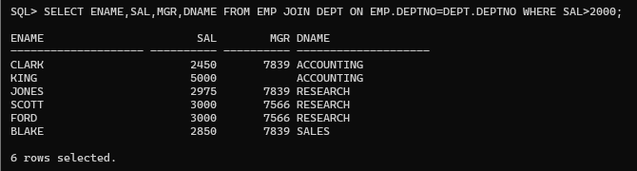
11. Display the EMPNO, ENAME, JOB, DEPTNO, DNAME, and LOC of employees. Use LEFT OUTER JOIN.
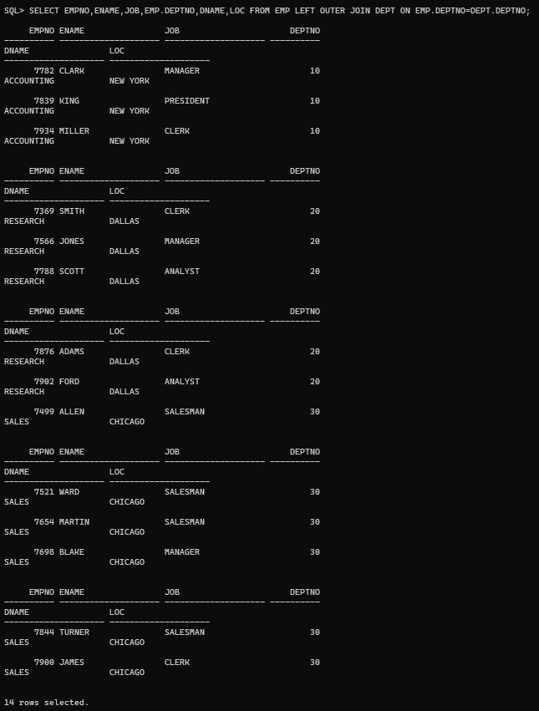

12. Display the ENAME and DNAME of employees. Use RIGHT OUTER JOIN.

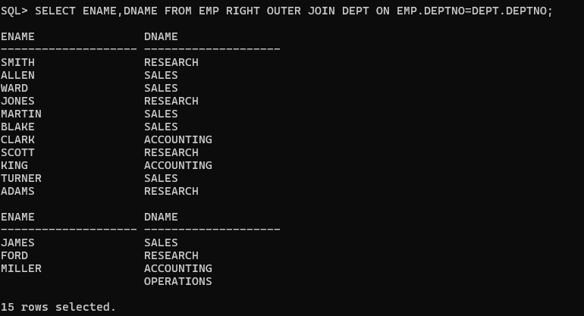
13. Display the EMPNO, DNAME, and LOC of employees. Use FULL OUTER JOIN

